**Lab - 1**

**Create the timetable of your class using the table tag.**

<!DOCTYPE html>

<html lang=*"en"*>

<head>

<meta charset=*"UTF-8"*>

<title>Time Table</title>

</head>

<body>

<h1 align=*"center"*></h1>

<table border=*"5"* cellspacing=*"0"* align=*"center"*>

<caption><b>TIME TABLE</b></caption>

<tr>

<td align=*"center"* height=*"50"* width=*"100"*>

</td>

<td align=*"center"* height=*"50"* width=*"100"*>

<b>09:15-10:05</b>

</td>

<td align=*"center"* height=*"50"* width=*"100"*>

<b>10:10-11:00</b>

</td>

<td align=*"center"* height=*"50"* width=*"100"*>

<b>11:05-11:55</b>

</td>

<td align=*"center"* height=*"50"* width=*"100"*>

<b>12:00-12:50</b>

</td>

<td align=*"center"* height=*"50"* width=*"100"*>

</td>

<td align=*"center"* height=*"50"* width=*"100"*>

<b>13:50-14:40</b>

</td>

<td align=*"center"* height=*"50"* width=*"100"*>

<b>14:45-15:35</b>

</td>

<td align=*"center"* height=*"50"* width=*"100"*>

<b>15:40-16:30</b>

</td>

<td align=*"center"* height=*"50"* width=*"100"*>

<b>16:35-17:25</b>

</td>

</tr>

<tr>

<td align=*"center"* height=*"50"*>

<b>Monday</b>

</td>

<td colspan=*"2"* align=*"center"* height=*"50"*>

CSE304<br>Dr Pronaya Bhattacharya[309881]<br>CLAB223

</td>

<td colspan=*"2"* align=*"center"* height=*"50"*>

IT404<br>Dr Moumita Basu[307044]<br>CLAB_222

</td>

<td rowspan=*"5"* align=*"center"* height=*"50"*>

L<br>U<br>N<br>C<br>H

</td>

<td align=*"center"* height=*"50"* width=*"100"*>

</td>

<td align=*"center"* height=*"50"* width=*"100"*>

GRMN121<br>Ms Tsira Gabatashvili<br>ACADEMIC - 403

</td>

<td align=*"center"* height=*"50"* width=*"100"*>

IT301<br>Mr Saubhik Bandyopadhyay[26437]<br>414

</td>

<td align=*"center"* height=*"50"* width=*"100"*>

</td>

</tr>

<tr>

<td align=*"center"* height=*"50"*><b>Tuesday</b></td>

<td align=*"center"* height=*"50"* width=*"100"*>

</td>

<td align=*"center"* height=*"50"* width=*"100"*>

CSE304<br>Dr Pronaya Bhattacharya[309881]<br>414

</td>

<td align=*"center"* height=*"50"* width=*"100"*>

CSE311<br>Mr Dhritiman Mukherjee[27474]<br>414

</td>

<td align=*"center"* height=*"50"* width=*"100"*>

IT404<br>Dr Moumita Basu[307044]<br>414

</td>

<td align=*"center"* height=*"50"* width=*"100"*>

IT301<br>Mr Saubhik Bandyopadhyay[26437]<br>414

</td>

<td align=*"center"* height=*"50"* width=*"100"*>

SKE309<br>Mr Dhritiman Mukherjee[27474]<br>414

</td>

<td align=*"center"* height=*"50"* width=*"100"*>

</td>

<td align=*"center"* height=*"50"* width=*"100"*>

</td>

</tr>

<tr>

<td align=*"center"* height=*"50"*><b>Wednesday</b></td>

<td align=*"center"* height=*"50"* width=*"100"*>

CSE401<br>Mr Tamoghna Mukherjee[25895]<br>414

</td>

<td align=*"center"* height=*"50"* width=*"100"*>

IT404<br>Dr Moumita Basu[307044]<br>414

</td>

<td align=*"center"* height=*"50"* width=*"100"*>

CSE304<br>Dr Pronaya Bhattacharya[309881]<br>414

</td>

<td align=*"center"* height=*"50"* width=*"100"*>

</td>

<td align=*"center"* height=*"50"* width=*"100"*>

CSE311<br>Mr Dhritiman Mukherjee[27474]<br>414

</td>

<td align=*"center"* height=*"50"* width=*"100"*>

</td>

<td align=*"center"* height=*"50"* width=*"100"*>

</td>

<td align=*"center"* height=*"50"* width=*"100"*>

</td>

</tr>

<tr>

<td align=*"center"* height=*"50"*><b>Thursday</b></td>

<td colspan=*"2"* align=*"center"* height=*"50"*>

CSE401<br>Dr Moumita Basu[307044]<br>CLAB223

</td>

<td align=*"center"* height=*"50"* width=*"100"*>

IT301<br>Mr Saubhik Bandyopadhyay[26437]<br>414

</td>

<td align=*"center"* height=*"50"* width=*"100"*>

CSE401<br>Dr Moumita Basu[307044]<br>414

</td>

<td align=*"center"* height=*"50"* width=*"100"*>

CSE304<br>Dr Pronaya Bhattacharya[309881]<br>414

</td>

<td align=*"center"* height=*"50"* width=*"100"*>

</td>

<td align=*"center"* height=*"50"* width=*"100"*>

</td>

<td align=*"center"* height=*"50"* width=*"100"*>

</td>

</tr>

<tr>

<td align=*"center"* height=*"50"*><b>Friday</b></td>

<td align=*"center"* height=*"50"* width=*"100"*>

</td>

<td align=*"center"* height=*"50"* width=*"100"*>

CSE401<br>Mr Tamoghna Mukherjee[25895]<br>414

</td>

<td align=*"center"* height=*"50"* width=*"100"*>

IT404<br>Dr Moumita Basu[307044]<br>414

</td>

<td align=*"center"* height=*"50"* width=*"100"*>

CSE311<br>Mr Dhritiman Mukherjee[27474]<br>414

</td>

<td colspan=*"2"* align=*"center"* height=*"50"*>

IT301<br>Dr Sujoy Chatterjee[309561]<br>CLAB_222

</td>

<td align=*"center"* height=*"50"* width=*"100"*>

</td>

<td align=*"center"* height=*"50"* width=*"100"*>

</td>

</tr>

</table>

</body>

</html>

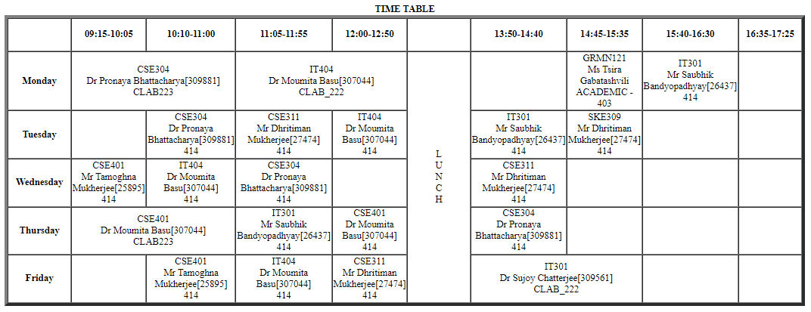

**Lab - 2**

**Create your profile page i.e. educational details, hobbies, achievement etc.**

<!DOCTYPE html>

<html lang=*"en"*>

<head>

<meta charset=*"UTF-8"*>

<title>Profile</title>

</head>

<body>

<B><font size=*"5"*><center>PROFILE</center></font></B><br>

<table border=*"1"* align=*"center"* cellspacing=*"5"* cellpadding=*"5"*>

<tr>

<td>

<b>Name: </b>Rohit Mukherjee<br><b>Email Address: </b>rohitmukherjee2002@gmail.com<br><b>Phone Number: </b>9073272265

</td>

<td>

<b>Address: </b>B-14/345,<br>Kalyani, Nadia, Pin-741235<br>West Bengal

</td>

</tr>

<tr>

<td colspan=*"3"*>

<hr><b>Objective</b><hr>Hardworking student seeking internship. Ready to utilize my skills and passion to further the mission of a company.<br>Technologically adept, offering experience with advanced computer skills. Bringing forth a positive attitude and<br>the willingness and motivation to learn new programs.

</td>

</tr>

<tr>

<td colspan=*"3"*>

<hr><b>Skills</b><hr>C, C++, SQL, Python, Java

</td>

</tr>

<tr>

<td colspan=*"3"*>

<hr><b>Educational Details</b><hr><center><table cellspacing=*"5"* cellpadding=*"5"* border=*"2"*>

<tr>

<td><center>Examination/Degree</center></td>

<td><center>Board/University</center></td>

<td><center>Passing Year</center></td>

<td><center>Result</center></td>

</tr>

<tr>

<td><center>Secondary</center></td>

<td><center>WBBSE</center></td>

<td><center>2018</center></td>

<td><center>90.86%</center></td>

</tr>

<tr>

<td><center> Higher Secondary</center></td>

<td><center>WBCHSE</center></td>

<td><center>2020</center></td>

<td><center>90.40%</center></td>

</tr>

<tr>

<td><center>B.Tech CSE</center></td>

<td><center>Amity University Kolkata</center></td>

<td><center>Expected 2024</center></td>

<td><center>8.63 CGPA</center></td>

</tr>

</table></center>

</td>

</tr>

<tr>

<td colspan=*"3"*>

<hr><b>Hobbies</b><hr>Gardening, Travelling, Cooking

</td>

</tr>

<tr>

<td colspan=*"3"*>

<hr><b>Achievement</b><hr>Passed CEH Master and ranked 5th globally in 2023

</td>

</tr>

</table>

</body>

</html>

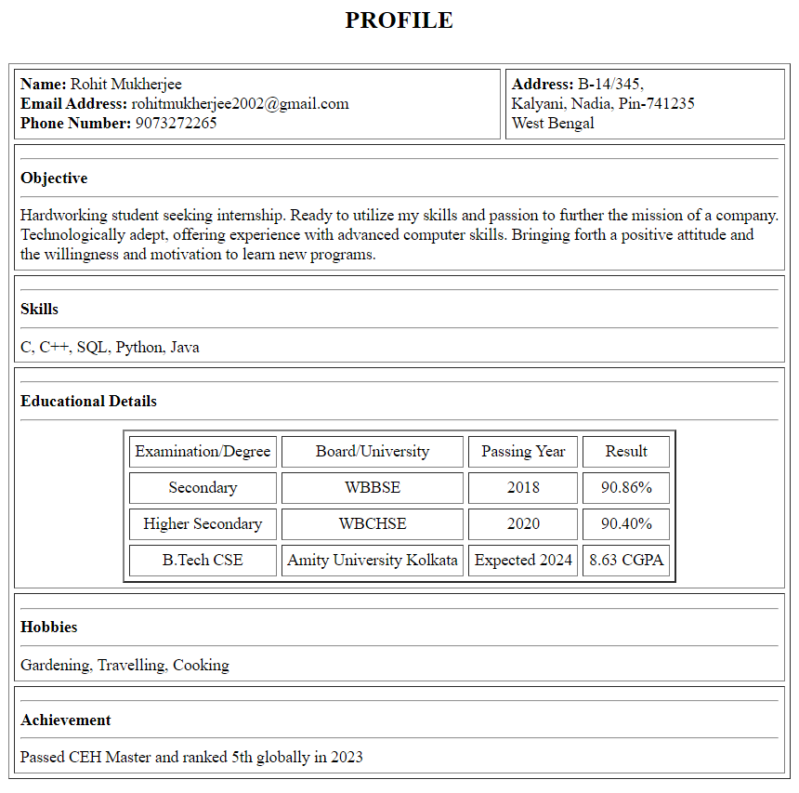

**Lab - 3**

**Create a registration form using different HTML components and print all the values in a JSP page.**

**HTML**

<!DOCTYPE html>

<html lang=*"en"*>

<head>

<meta charset=*"UTF-8"*>

<title>Registration Form</title>

</head>

<body>

<h2>Form</h2>

<form method=*"post"* action=*Registration_Form.jsp* name=*"registration-forms"*>

Name<input type=*"text"* name=*"name"* size=*"30"*/><br/><br>

Username<input type=*"text"* name=*"user"* size=*"30"*/><br/><br>

Password<input type=*"password"* name=*"password"* size=*"30"*/><br/><br>

Confirm Password<input type=*"password"* name=*"confirm password"* size=*"30"*/><br/><br>

Gender

<select>

<option>Male</option>

<option>Female</option>

</select><br/><br>

Qualification

<select>

<option>B.Tech</option>

<option>BBA</option>

<option>M.Tech</option>

<option>MBA</option>

</select><br/><br>

Hobbies

<input type=*"checkbox"*>Cooking

<input type=*"checkbox"*>Reading

<input type=*"checkbox"*>Travelling<br/><br>

Bio</br>

<textarea rows=*"5"* cols=*"30"* placeholder=*"Enter your bio"*></textarea><br/><br>

<input type=*"submit"* value=*"Submit"* id=*"submit-btn"* class=*"submit-btn"*/>

</form>

</body>

</html>

**JSP**

<%@ page contentType=*"text/html;charset=UTF-8"* language=*"java"* %>

<%@ page import=*"java.io.PrintWriter"* %>

<html>

<head>

<title>Registration Form</title>

</head>

<body>

<%

String nm = request.getParameter("name");

PrintWriter out = response.getWriter();

out.println("<h1>Welcome " + nm + "</h1>" + System.lineSeparator());

out.println("<h1>You have registered successfully!</h1>");

%>

</body>

</html>

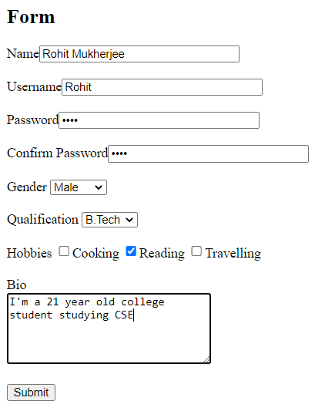



**Lab - 4**

**Design a web application that checks if your age is over 18 or not and displays different message.**

**HTML**

<!DOCTYPE html>

<html lang=*"en"*>

<head>

<meta charset=*"UTF-8"*>

<title>Age Checker</title>

</head>

<body>

<h2 align=*"center"*>Form</h2>

<form align=*"center"* action=*"Age_Checker.jsp"*>

<label for=*"name"*>Name:</label><br>

<input type=*"text"* id=*"name"* name=*"name"* placeholder=*"Name"*><br>

<label for=*"age"*>Age:</label><br>

<input type=*"text"* id=*"age"* name=*"num"* placeholder=*"Age"*><br><br>

<input type=*"submit"* value=*"Check"*>

</form>

</body>

</html>

**JSP**

<%@ page contentType=*"text/html;charset=UTF-8"* language=*"java"* %>

<html>

<head>

<title>Age Checker</title>

</head>

<body>

<%

String str = request.getParameter("name");

int age = Integer.parseInt(request.getParameter("num"));

if (age>=18)

{

out.println("<h1>Welcome " + str + " to this site</h1");

}

else

{

out.println("<h1>Hello " + str + ", you are not authorized to visit the site</h1");

}

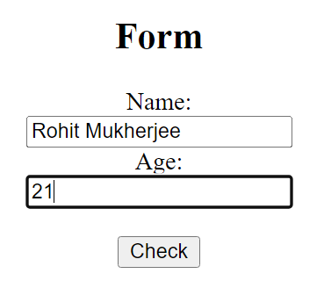%>

</body>

</html>

**

**Lab - 5**

**Design a calculator using JSP**

**HTML**

<!DOCTYPE html>

<html lang=*"en"*>

<head>

<meta charset=*"UTF-8"*>

<title>Calculator</title>

</head>

<body>

<h2>Calculator</h2>

<form action=*"Calculator.jsp"* method=*"post"*>

<table cellpadding=*"10"* cellspacing=*"10"*>

<tr>

<td>Number 1</td>

<td><input type=*"text"* name=*"num1"* id=*"num1"*></td>

</tr>

<tr>

<td>Number 2</td>

<td><input type=*"text"* name=*"num2"* id=*"num2"*></td>

</tr>

<tr>

<td><input type=*"radio"* name=*"r1"* id=*"add"* value=*"add"* >+</td>

<td><input type=*"radio"* name=*"r1"* id=*"min"* value=*"min"* >-</td>

</tr>

<tr>

<td><input type=*"radio"* name=*"r1"* id=*"sub"* value=*"sub"* >*</td>

<td><input type=*"radio"* name=*"r1"* id=*"div"* value=*"div"* >/</td>

</tr>

<tr>

<td><input type=*"submit"* value=*"Calculate"*></td>

</tr>

</table>

</form>

</body>

</html>

**JSP**

<%@ page contentType=*"text/html;charset=UTF-8"* language=*"java"* %>

<html>

<head>

<title>Calculator</title>

</head>

<body>

<%

String str = request.getParameter("r1");

int num1;

int num2;

int tot=0;

num1 = Integer.parseInt(request.getParameter("num1"));

num2 = Integer.parseInt(request.getParameter("num2"));

if ("add".equals(str))

{

tot = num1 + num2;

}

else if ("min".equals(str))

{

tot = num1 - num2;

}

else if ("sub".equals(str))

{

tot = num1 * num2;

}

else if ("div".equals(str))

{

tot = num1 / num2;

}

Integer result = new Integer(tot);

out.println("<h2>The result is: " + result.toString() + "</h2>");

%>

</body>

</html>

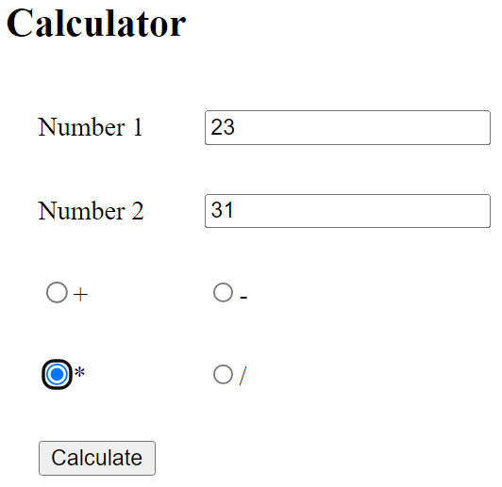

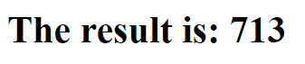

**Lab - 6**

**Implement the session management using cookies.**

**Web.xml**

<?xml version=*"1.0"* encoding=*"UTF-8"*?>

<web-app xmlns:xsi=*"http://www.w3.org/2001/XMLSchema-instance"* xmlns=*"http://xmlns.jcp.org/xml/ns/javaee"* xsi:schemaLocation=*"http://xmlns.jcp.org/xml/ns/javaee http://xmlns.jcp.org/xml/ns/javaee/web-app_4_0.xsd"* id=*"WebApp_ID"* version=*"4.0"*>

<display-name>SecondProject</display-name>

<servlet>

<servlet-name>s1</servlet-name>

<servlet-class>test.FirstServlet</servlet-class>

</servlet>

<servlet-mapping>

<servlet-name>s1</servlet-name>

<url-pattern>/servlet1</url-pattern>

</servlet-mapping>

<servlet>

<servlet-name>s2</servlet-name>

<servlet-class>test.SecondServlet</servlet-class>

</servlet>

<servlet-mapping>

<servlet-name>s2</servlet-name>

<url-pattern>/servlet2</url-pattern>

</servlet-mapping>

</web-app>

**HTML**

<!DOCTYPE html>

<html>

<head>

<title>Cookie</title>

</head>

<body>

<form action=*"servlet1"* method=*"post"*>

Name:<input type=*"text"* name=*"userName"*/><br/>

<input type=*"submit"* value=*"go"*/>

</form>

</body>

</html>

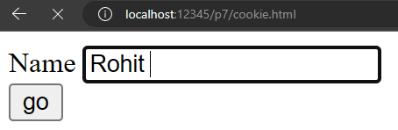

**FirstServlet**

package test;

import java.io.*;

import javax.servlet.annotation.WebServlet;

import javax.servlet.http.Cookie;

import javax.servlet.http.HttpServlet;

import javax.servlet.http.HttpServletRequest;

import javax.servlet.http.HttpServletResponse;

@WebServlet("/FirstServlet")

public class FirstServlet extends HttpServlet {

public void doPost(HttpServletRequest request, HttpServletResponse response){

try{

response.setContentType("text/html");

PrintWriter out = response.getWriter();

String n=request.getParameter("userName");

out.print("Welcome "+n);

Cookie ck=new Cookie("uname",n);//creating cookie object

response.addCookie(ck);//adding cookie in the response

out.print("<form action=*'servlet2'* method=*'post'*>");

out.print("<input type=*'submit'* value=*'go'*>");

out.print("</form>");

out.close();

}

catch(Exception e){

System.out.println(e);

}

}

}

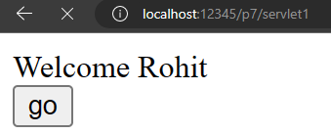

**SecondServlet**

package test;

import java.io.*;

import javax.servlet.annotation.WebServlet;

import javax.servlet.http.Cookie;

import javax.servlet.http.HttpServlet;

import javax.servlet.http.HttpServletRequest;

import javax.servlet.http.HttpServletResponse;

@WebServlet("/SecondServlet")

public class SecondServlet extends HttpServlet {

public void doPost(HttpServletRequest request, HttpServletResponse response){

try{

response.setContentType("text/html");

PrintWriter out = response.getWriter();

Cookie ck[]=request.getCookies();

for(int i=0;i<ck.length;i++){

if(ck[i].getName().equals("uname")){

out.print("Hello "+ck[i].getValue());

}

}

out.close();

}

catch(Exception e){

System.out.println(e);

}

}

}

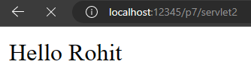

**Lab - 7**

**Implement the session management using hidden field.**

**Web.xml**<?xml version="1.0" encoding="UTF-8"?>

<display-name>p7</display-name>

<servlet>

<servlet-name>s1</servlet-name>

<servlet-class>test.FirstServlet</servlet-class>

</servlet>

<servlet-mapping>

<servlet-name>s1</servlet-name>

<url-pattern>/servlet1</url-pattern>

</servlet-mapping>

<servlet>

<servlet-name>s2</servlet-name>

<servlet-class>test.SecondServlet</servlet-class>

</servlet>

<servlet-mapping>

<servlet-name>s2</servlet-name>

<url-pattern>/servlet2</url-pattern>

</servlet-mapping>

</web-app>

**Html**

<!DOCTYPE html>

<html>

<head>

<meta charset="ISO-8859-1">

<title>Hidden Field</title>

</head>

<body>

<form action="servlet1" method="post">

Name:<input type="text" name="userName"/><br/>

<input type="submit" value="go"/>

</form>

</body>

</html>

**FirstServlet.java**

package test;

import java.io.*;

import javax.servlet.annotation.WebServlet;

import javax.servlet.http.HttpServlet;

import javax.servlet.http.HttpServletRequest;

import javax.servlet.http.HttpServletResponse;

import javax.servlet.http.HttpSession;

@WebServlet("/FirstServlet")

public class FirstServlet extends HttpServlet

{

private static final long serialVersionUID=1L;

public void doPost(HttpServletRequest request, HttpServletResponse response)

{

try

{

response.setContentType("text/html");

PrintWriter out=response.getWriter();

String n=request.getParameter("userName");

out.print("uname "+n);

HttpSession session=request.getSession();

session.setAttribute("Welcome", n);

out.print("<form action='servlet2' method='post'>");

out.print("<input type='hidden' name='userName'>");

out.print("<input type='submit' value='go'>");

out.print("</form>");

out.close();

}

catch(Exception e)

{

System.out.println(e);

}

}

}

**SecondServlet.java**

package test;

import java.io.*;

import javax.servlet.annotation.WebServlet;

import javax.servlet.http.HttpServlet;

import javax.servlet.http.HttpServletRequest;

import javax.servlet.http.HttpServletResponse;

import javax.servlet.http.HttpSession;

@WebServlet("/SecondServlet")

public class SecondServlet extends HttpServlet

{

private static final long serialVersionUID=1L;

public void doPost(HttpServletRequest request, HttpServletResponse response)

{

try

{

response.setContentType("text/html");

PrintWriter out=response.getWriter();

HttpSession session=request.getSession();

String n=(String)session.getAttribute("uname");

out.print("Hello"+n);

out.close();

}

catch(Exception e)

{

System.out.println(e);

}

}

}

**Lab - 8**

**Implement the session management using session.**

**Web.xml**<?xml version="1.0" encoding="UTF-8"?>

<display-name>p7</display-name>

<servlet>

<servlet-name>s1</servlet-name>

<servlet-class>test.FirstServlet</servlet-class>

</servlet>

<servlet-mapping>

<servlet-name>s1</servlet-name>

<url-pattern>/servlet1</url-pattern>

</servlet-mapping>

<servlet>

<servlet-name>s2</servlet-name>

<servlet-class>test.SecondServlet</servlet-class>

</servlet>

<servlet-mapping>

<servlet-name>s2</servlet-name>

<url-pattern>/servlet2</url-pattern>

</servlet-mapping>

</web-app>

**Html**

<!DOCTYPE html>

<html>

<head>

<meta charset="ISO-8859-1">

<title>Hidden Field</title>

</head>

<body>

<form action="servlet1" method="post">

Name:<input type="text" name="userName"/><br/>

<input type="submit" value="go"/>

</form>

</body>

</html>

**FirstServlet.java**

import java.io.*;

import javax.servlet.http.*;

public class FirstServlet extends HttpServlet

{

private static final long serialVersionUID=1L;

public void doGet(HttpServletRequest request, HttpServletResponse response)

{

try

{

response.setContentType("text/html");

PrintWriter out=response.getWriter();

String n=request.getParameter("userName");

out.print("Welcome "+n);

out.print("<form action='servlet2'>");

out.print("<input type='hidden' name='uname' value='"+n+"'>");

out.print("<input type='submit' value='go'>");

out.print("</form>");

out.close();

}

catch(Exception e)

{

System.out.println(e);

}

}

}

**SecondServlet.java**

import java.io.*;

import javax.servlet.http.*;

public class SecondServlet extends HttpServlet

{

private static final long serialVersionUID=1L;

public void doGet(HttpServletRequest request, HttpServletResponse response)

{

try

{

response.setContentType("text/html");

PrintWriter out=response.getWriter();

String n=request.getParameter("uname");

out.print("Hello "+n);

out.close();

}

catch(Exception e)

{

System.out.println(e);

}

}

}

**Lab - 9**

**Create web pages to store employee details of XYZ company. The details include empid, address, name, date of joining, gross salary. Create an admin login page and a page to display the record of all employees after the user has logged in successfully. Use the concept of java bean.**

**bdb.html**

<!DOCTYPE html PUBLIC "-//W3C//DTD XHTML 1.0 Transitional//EN" "http://www.w3.org/TR/xhtml1/DTD/xhtml1-transitional.dtd">

<html xmlns=*"http://www.w3.org/1999/xhtml"*>

<head>

<meta http-equiv=*"Content-Type"* content=*"text/html; charset=utf-8"* />

<title>Untitled Document</title>

</head>

<body>

<pre>

<form name=*"form1"* method=*"post"* action=*""*>

<p><a href=*"binsert.html"*>INSERT</a></p>

<p><a href=*"bdelete.html"*>DELETE</a></p>

<p><a href=*"bupdate.html"*>UPDATE</a></p>

<p><a href=*"bfetch.html"*>FETCH</a></p></form>

</pre>

</body>

</html>

**binsert.html**

<!DOCTYPE html PUBLIC "-//W3C//DTD HTML 4.01 Transitional//EN" "http://www.w3.org/TR/html4/loose.dtd">

<html>

<head>

<meta http-equiv=*"Content-Type"* content=*"text/html; charset=ISO-8859-1"*>

<title>Insert title here</title>

</head>

<body>

<form action=*"binsert.jsp"* method=*post* >

<p> EID <input type=*"text"* name=*"eid"*></p>

<p> NAME <input type=*"text"* name=*"name"*> </p>

<p> DEGN <input type=*"text"* name=*"desg"*></p>

<input type=*"submit"* name=*"Submit"* value=*"INSERT"*> <p>&nbsp; </p>

<p>&nbsp;</p>

<p>&nbsp;</p>

<p>&nbsp;</p>

<p>&nbsp;</p>

<p>&nbsp;</p>

<p>&nbsp;</p>

<p>&nbsp;</p>

<p>&nbsp;</p>

<p>&nbsp;</p>

<p>&nbsp;</p>

</form>

<p>&nbsp;</p>

<p>&nbsp;</p>

<p>&nbsp;</p>

</body>

</html>

**binsert.jsp**

<%@ page import=*"java.sql.*"*%>

<%@ page language=*"java"* contentType=*"text/html; charset=ISO-8859-1"*

pageEncoding=*"ISO-8859-1"*%>

<!DOCTYPE html PUBLIC "-//W3C//DTD HTML 4.01 Transitional//EN" "http://www.w3.org/TR/html4/loose.dtd">

<html>

<head>

<meta http-equiv=*"Content-Type"* content=*"text/html; charset=ISO-8859-1"*>

<title>Insert title here</title>

</head>

<body>

<jsp:useBean id=*"ob"* class=*"emp.Employee"* scope=*"page"* >

<jsp:setProperty name=*"ob"* property=*"*"* />

</jsp:useBean>

<%

out.println("eid:"+request.getParameter("eid"));

int t=ob.insert();

if(t>0)

out.println("Inserted Successfully");

%>

</body>

</html>

**bfetch.html**

<!DOCTYPE html PUBLIC "-//W3C//DTD HTML 4.01 Transitional//EN" "http://www.w3.org/TR/html4/loose.dtd">

<html>

<head>

<meta http-equiv=*"Content-Type"* content=*"text/html; charset=ISO-8859-1"*>

<title>Insert title here</title>

</head>

<body>

<body>

<form action=*"bfetch.jsp"* method=*post*>

<PRE>

EID <input type=*"text"* name=*"n1"*></p>

<input type=*"submit"* name=*"Submit"* value=*"FETCH"*><p>&nbsp; </p><p>&nbsp; </p>

</PRE>

</form>

</body>

</html>

**bfetch.jsp**

<%@ page import=*"java.sql.*"*%>

<%@ include file=*"connect.jsp"* %>

<%@ page language=*"java"* contentType=*"text/html; charset=ISO-8859-1"*

pageEncoding=*"ISO-8859-1"*%>

<!DOCTYPE html PUBLIC "-//W3C//DTD HTML 4.01 Transitional//EN" "http://www.w3.org/TR/html4/loose.dtd">

<html>

<head>

<meta http-equiv=*"Content-Type"* content=*"text/html; charset=ISO-8859-1"*>

<title>Insert title here</title>

</head>

<body>

<jsp:useBean id=*"ob3"* class=*"emp.Employee"* scope=*"page"* >

<jsp:setProperty name=*"ob3"* property=*"eid"* param=*"n1"* />

</jsp:useBean>

<%

try{

ob3.fetch();

}catch(Exception e){e.printStackTrace();}

%>

Name <jsp:getProperty name=*"ob3"* property=*"name"* /> <br>

Degn <jsp:getProperty name=*"ob3"* property=*"desg"* /> <br>

</body>`

</html>

bupdate.html

<!DOCTYPE html PUBLIC "-//W3C//DTD HTML 4.01 Transitional//EN" "http://www.w3.org/TR/html4/loose.dtd">

<html>

<head>

<meta http-equiv=*"Content-Type"* content=*"text/html; charset=ISO-8859-1"*>

<title>Insert title here</title>

</head>

<body>

<form method=*"post"* action=*"bedit.jsp"*>

<p> EID <input type=*"text"* name=*"n2"*></p>

<input type=*"submit"* name=*"Submit"* value=*"UPDATE"*><p>&nbsp; </p><p>&nbsp; </p>

</form>

</body>

</html>

**bedit.jsp**

<!DOCTYPE html PUBLIC "-//W3C//DTD HTML 4.01 Transitional//EN" "http://www.w3.org/TR/html4/loose.dtd">

<html>

<head>

<meta http-equiv=*"Content-Type"* content=*"text/html; charset=ISO-8859-1"*>

<title>Insert title here</title>

</head>

<body>

<jsp:useBean id=*"ob2"* class=*"emp.Employee"* scope=*"session"* >

<jsp:setProperty name=*"ob2"* property=*"eid"* param=*"eid"* />

</jsp:useBean>

<%

ob2.fetch();

%>

<form action=*"bupdate.jsp"* method=*"post"*>

Name <input type=*text* name=*"name"* value=<%=ob2.getName()%>>

Desg <input type=*text* name=*"desg"* value=<%=ob2.getDesg()%>>

<input type=*submit* value=*UPDATE*>

</form>

</body>

</html>

**bupdate.jsp**

<%@ page language=*"java"* contentType=*"text/html; charset=ISO-8859-1"*

pageEncoding=*"ISO-8859-1"*%>

<!DOCTYPE html PUBLIC "-//W3C//DTD HTML 4.01 Transitional//EN" "http://www.w3.org/TR/html4/loose.dtd">

<html>

<head>

<meta http-equiv=*"Content-Type"* content=*"text/html; charset=ISO-8859-1"*>

<title>Insert title here</title>

</head>

<body>

<jsp:useBean id=*"ob2"* class=*"emp.Employee"* scope=*"session"* >

<jsp:setProperty name=*"ob2"* property=*"*"* />

</jsp:useBean>

<%

ob2.setName(request.getParameter("name"));

ob2.setDesg(request.getParameter("desg"));

int t=ob2.update();

out.println("Updated called");

if(t>0)

out.println("Updated Successfully");

%>

</body>

</html>

Employee.java(Bean)

package emp;

import java.sql.*;

public class Employee {

private String eid , name,desg;

public void setEid(String eid){

this.eid=eid;

}

public String getEid(){

return eid;

}

public void setName(String name)

{

this.name=name;

}

public String getName()

{

return name;

}

public void setDesg(String desg)

{

this.desg=desg;

}

public String getDesg()

{

return desg;

}

public int insert()

{

Connection conn= null;

ConnectEmp c=new ConnectEmp();

int t=0;

try{

conn=c.connect();

PreparedStatement pst=conn.prepareStatement("insert into emp_bit values(?,?,?)");

pst.setString(1,eid);

pst.setString(2,name);

pst.setString(3,desg);

t=pst.executeUpdate();

conn.close();

}

catch(Exception e)

{

}

return t;

}

public int delete()

{

Connection conn= null;

ConnectEmp c=new ConnectEmp();

int t=0;

try{

conn=c.connect();

PreparedStatement pst=conn.prepareStatement("delete from emp_bit where eid=?");

pst.setString(1,eid);

t=pst.executeUpdate();

conn.close();

}

catch(Exception e)

{

}

return t;

}

public int update()

{

Connection conn= null;

ConnectEmp c=new ConnectEmp();

System.*out*.println("Inside Update"+getName());

System.*out*.println("Inside Update"+getDesg());

System.*out*.println("Inside Update"+getEid());

int t=0;

try{

conn=c.connect();

PreparedStatement pst=conn.prepareStatement("update emp_bit set name=?,desg=? where eid=?");

pst.setString(1,name);

pst.setString(2,desg);

pst.setString(3,eid);

System.*out*.println("update emp_bit set name='"+name+"'desg='"+desg+"'where eid='"+eid+"'");

t=pst.executeUpdate();

conn.close();

}

catch(Exception e)

{

}

return t;

}

public void fetch()

{

Connection conn= null;

ConnectEmp c=new ConnectEmp();

int t=0;

try{

conn=c.connect();

PreparedStatement pst=conn.prepareStatement("select * from emp_bit where eid=?");

pst.setString(1,eid);

ResultSet rs=pst.executeQuery();

while(rs.next()){

eid=rs.getString(1);

name=rs.getString(2);

desg=rs.getString(3);

//PrintWriter pw=response.

System.*out*.println("id="+eid);

conn.close();

}

}

catch(Exception e)

{

}

}

}

**ConnectEmp.java**

package emp;

import java.sql.*;

public class ConnectEmp {

public Connection conn=null;

public Connection connect(){

try{

Class.*forName*("oracle.jdbc.driver.OracleDriver");

conn = DriverManager.*getConnection*("jdbc:oracle:thin:@localhost:1521:XE","system","system");

System.*out*.println("Connected");

}

catch(Exception e){}

return conn;

}

}